

**INSTALLATION MANUAL**

### **Table of Contents**

### **Applicable Version**………………..…....……………………………….……………………….1

### **Installation**....………………………….……….……………………………………………………1

### **Configuring Ingenico**………………..……………………………………………………………3

### **Applicable versions**

|  |  |
| --- | --- |
| **Applications** | **Versions** |
| PHP | 7.3.x |
| cs-cart | 4.12.x |

### **Installation**

Please follow the given steps to install and run the Ingenico Payment Gateway module

1. Download the ingenico folders and create the zip file or directly download the zip file.

2. Go to Add-ons->Manage add-ons->click on ‘+’ icon on top right corner.  
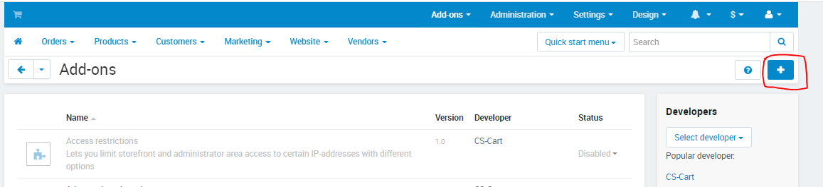

3. Select the zip file which you created or downloaded and click on the upload & install button.

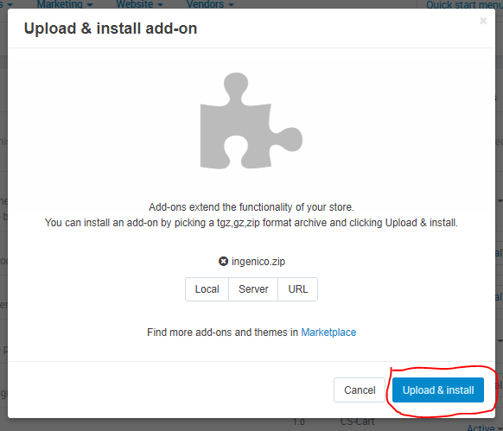

4. After successful installation you can see the ‘Ingenico Payment’ in the addons list, you need to activate it using the dropdown icon on the right side.

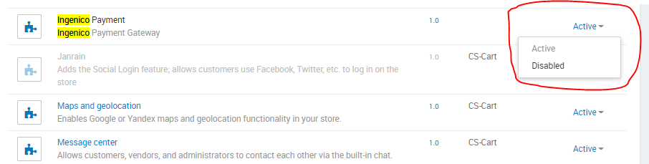

**Configuration**

1. To configure this payment method click go to administration->Payment Methods and then click on the ‘+’ icon.

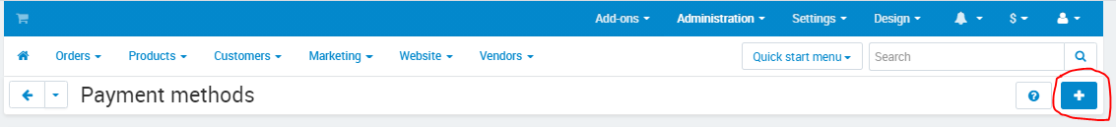

1. Setup it as below :

**General :**

|  |  |
| --- | --- |
| **Column Name** | **Description** |
| Name | Ingenico |
| Processor | Ingenico |
| Icon | you can select the ingenico icon given with the kit. |

**Configure :**

|  |  |
| --- | --- |
| **Column Name** | **Description** |
| Merchant ID | Enter Merchant Code |
| Merchant Scheme Code | Enter Scheme Code |
| Salt | Enter Salt. |
| Payment Type | For Test mode Select ‘Test’ and for Live mode select ‘Live’ |
| Currency | Select the Currency |

Click on the create button and Ingenico Payment Gateway is now configured & ready to use.

**Advanced Configuration**

There are also some advanced configuration options you may consider as shown below:

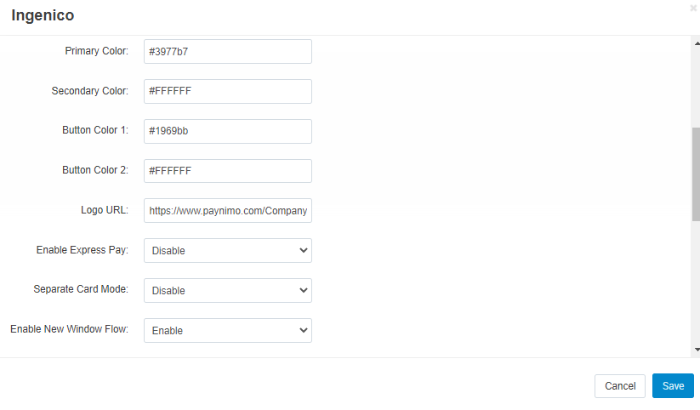

## **Features List**

### **Dual verification of response**

We are validating responses with a hash value and call again Payment Gateway for dual verification from the payment gateway before updating to the order status.

### **Reconciliation**

Merchants can update the pending status of the order automatically if the payments are successful. The page link can be found on Admin Dashboard under Ingenico Payment : Important Links->Reconciliation  
  
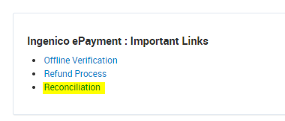

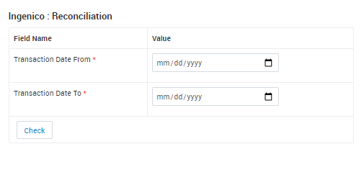

### **S2S Verification**

If we do not receive any response from the payment gateway then after 30 mins, we will get a response from the server and based on the response it will update order status.

To configure S2S URL, contact prod team.

S2S url example: http://example.com[/](http://localhost/op3032demo/index.php?route=extension/payment/ingenico/s2sverification&msg=0300%7Csuccess%7CNA%7C506214%7C470%7C1325863698%7C106.00%7C%7Bitc:%7D%7Bcustname:Russel)admin.php?dispatch=ingenico.s2s&action=s2sverification&msg=

### **MCG**

It supports the multi currency like USD, GBP, SGD and a lot more.

### **Offline Verification**

Merchants can verify the status of their payment by using the Payment Verification page. The page link can be found on Admin Dashboard under Ingenico Payment : Important Links->Offline Verification

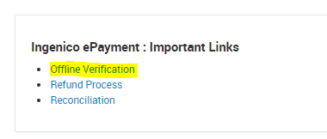  
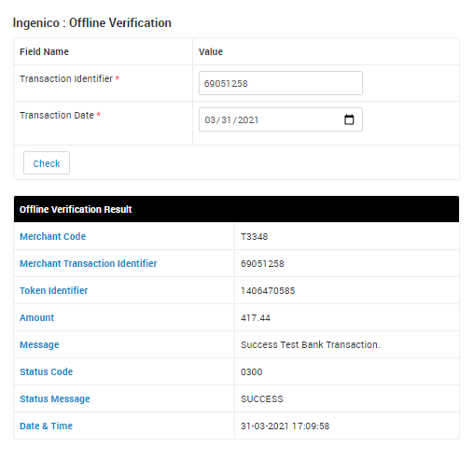



### **Refund**

Merchants should be able to process the refund online for the order whose payment has been done via Ingenico.

To refund an order, page link can be found on Admin Dashboard under Ingenico Payment : Important Links->Refund Process

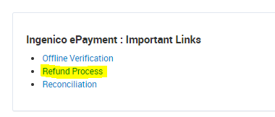

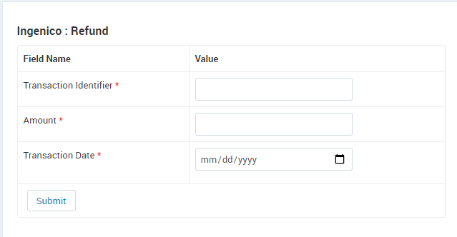

### **Embed Payment Gateway**

After enabling this setting, payment gateway displays like embedded on the page instead of pop-up so user experience would be good.

## **Documentation link**

[**https://www.tecprocesssolution.com/proto/p2m/client/salt-based-documentation.htm#online**](https://www.tecprocesssolution.com/proto/p2m/client/salt-based-documentation.htm#online)